F. EXAMPLE PROJECTS WHICH BEST ILLUSTRATE PROPOSED TEAM’S QUALIFICATIONS FOR THIS CONTRACT  (Present as many projects as requested by the agency, or 10 projects, if not specified. Complete one Section F for each project.) |  |  |  |  |  |  | 20. EXAMPLE PROJECT KEY NUMBER  04
21. TITLE AND LOCATION (CITY AND STATE)  SR 60 / Archibald Avenue IC Project, Ontario |  |  |  | 22. YEAR COMPLETED
 |  |  |  | PROFESSIONAL SERVICES  2023 |  |  | CONSTRUCTION (IF APPLICABLE)
23. PROJECT OWNER’S INFORMATION
a. PROJECT OWNER  SBCTA / Caltrans District 8 |  | b. POINT OF CONTACT NAME  Kristi Harris, PE |  |  | c. POINT OF CONTACT TELEPHONE NUMBER  (435) 574-8767
24. BRIEF DESCRIPTION OF PROJECT AND RELEVANCE TO THIS CONTRACT (INCLUDE SCOPE, SIZE AND COST)
S2 provided construction management service on this $17 million Archibald Avenue widening project under SR 60. Local streets were widened; freeway ramps were pushed out as part of this project.
- Construction Management
- Construction Inspection
- CPM Review and Analysis
- Claims Analysis
- Field Engineering and Support
- Contract Change Orders negotiations and processing
- Progress Pay Estimates
- Review & approve Submittals and RFI’s
- Project Controls and Contract Administration
Project Relevance

S2 provided RE and inspection services at the later part of this project to wrap up the construction and resolve all issues related to delays and claims. Most of the delays and claims were caused by conflicting staging plans, changes in the roadway structural section (from HMA to JPCP) after the project started, differing site conditions, constraints caused by the water districts because of COVID, time related overhead, and extra work payments for SWPPP and flagging.

S2 reviewed contractor’s time impact analysis, prepared internal TIA for comparison, reviewed extra work bills, reviewed third-party delay clause in the contract; and prepared a thirteen-page claims report for SBCTA submittal. Later, S2 held meetings with SBCTA and the contractor; all claims were resolved and settled for a fraction of the total claims submitted by the contractor. S2 also prepared DRB reports and made a presentation to the DRB.

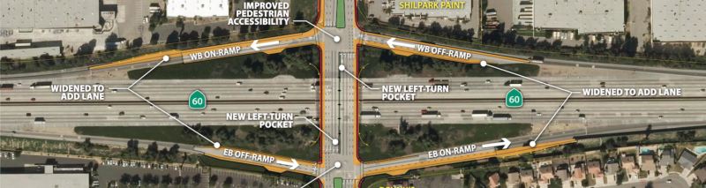

25. FIRMS FROM SECTION C INVOLVED WITH THIS PROJECT
a. | S2 Engineering, Inc. |  | Rancho Cucamonga, CA |  |  | Construction Management / Scheduling / Claims Analysis
STANDARD FORM 330 (REV. 7/2021)

